**ABRF/LMRG**

**Image Analysis Study**

FISH in *C. elegans* (and associated calibration image[s])

**Proposal:**

Segment the objects in a fluorescence z-stack image and provide:

* Centroid location in microns (um) for each spot: x, y, and z coordinates listed in separate columns. Labels x, y, and z.
* Integrated Intensity. Label intensity.
* 3D volume image of your segmented image
* Download CSV template [here](https://drive.google.com/file/d/10Y3er22JJAVUjtivFoP0fxJRAz9ma057/view?usp=sharing). (LastName_FirstName_ImageName.csv)

**Input:**

Four different z-stack images that vary in their signal-to-noise ratio and the clustering of their objects of FISH staining in *C. elegans*.

Voxel dimensions: 0.162x0.162x0.200 um

<https://drive.google.com/drive/folders/1dT25oJweQZejjCxWIuVJ6vm7rZAzKFwi?usp=sharing>

Calibration file

Voxel dimensions: 1x1x1 um

**FishPipeline** - 3m 22s

/Users/mcruz/Documents/Tutorials/ABRFTutorial/Fish/Documentation/NewFishPureCP.cppipe

**Importing data in CellProfiler**

1. Highlight the **Images** module.
   1. Drag-and-drop the images you will analyze into the Images module window.

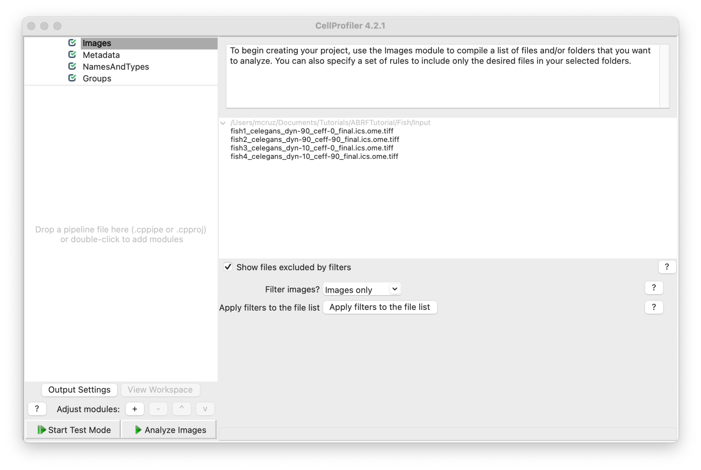

Load the pipeline file (.cppipe). Drag-and-Drop the file or go to File->Import->Pipeline from File…

Note: The pipeline should populate all information needed, but it’s always a good practice to check if everything is fine. 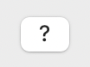

**Tip: Use the question marker button to learn more or if you have any doubt.**

1. Highlight the **NameAndType** module.

The **NamesAndTypes** module gives each image a meaningful name by which modules in the analysis pipeline will refer to it. This module will also let you define an image stack that should be processed as a whole 3D volume.

1. Assign a name to: All images This is the simplest choice and the appropriate one because we have only one kind of image.
2. Process as 3D: Yes Selecting “Yes” will load the files as volumes
3. Populate the fields for “Relative Pixel Spacing”. This calibration affects modules that handle 3D images as volumes.

The relative pixel spacing was provided and is 0.162 um in x and y and 0.200 um in z. To run the calibration file please change the relative pixel spacing to 1x1x1 um.

1. Assign the images “variable names” that describe the contents in the image. For example, use the name "FISH" or "Worm" or something else that will remind you what the image is.
2. Hit the "update" button to populate

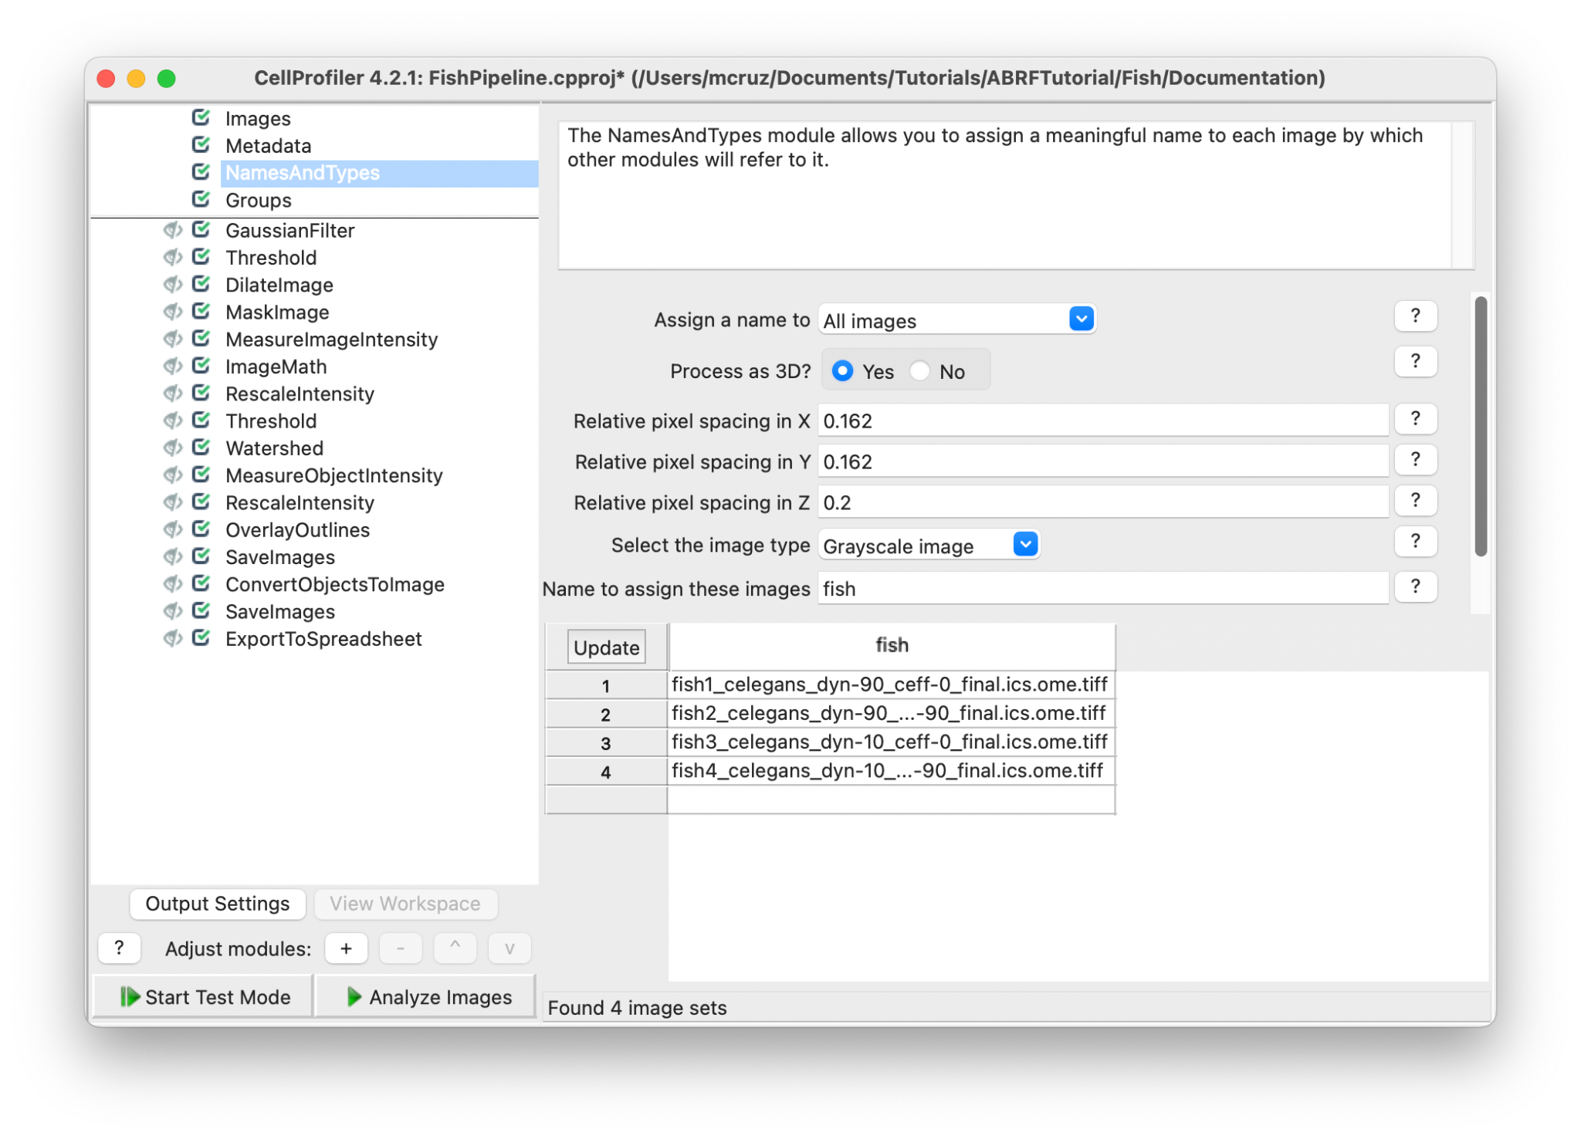

This pipeline can be divided into three main parts: Image processing, segmentation and measurement/export.

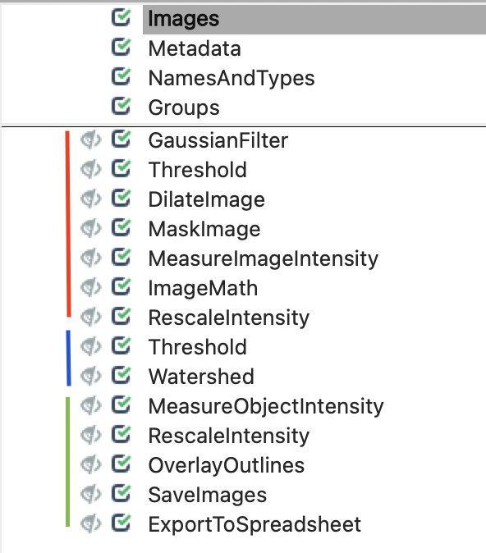

**Image processing:**

The image processing is used to prepare the image for a correct segmentation, in this case we have images with different signal-to-noise ratio (SNR) and an important background signal from the worm. We will first create a mask image of the worm and use this to remove the noise and background from the original image. These modules should normalize the images making the segmentation process work through all image sets.

1. Hit the start test mode button.

**Tip:** You can select different image sets. For that you can go to the main tab, hit the test tab and choose another image set or you can hit the Next Image Set button.

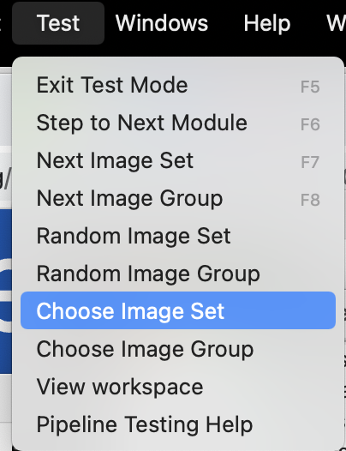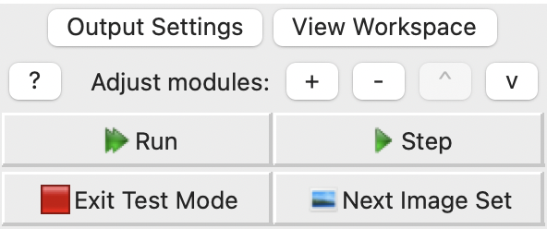

1. **GaussianFilter** module: select the input image “fish” (or whatever the name you give for your images in **NamesAndTypes** module), name the output image as “GaussianFilter” and a Sigma value of “3” (larger sigmas induce more blurring). This module will blur the image and make the worm/background more evident for the threshold filter.

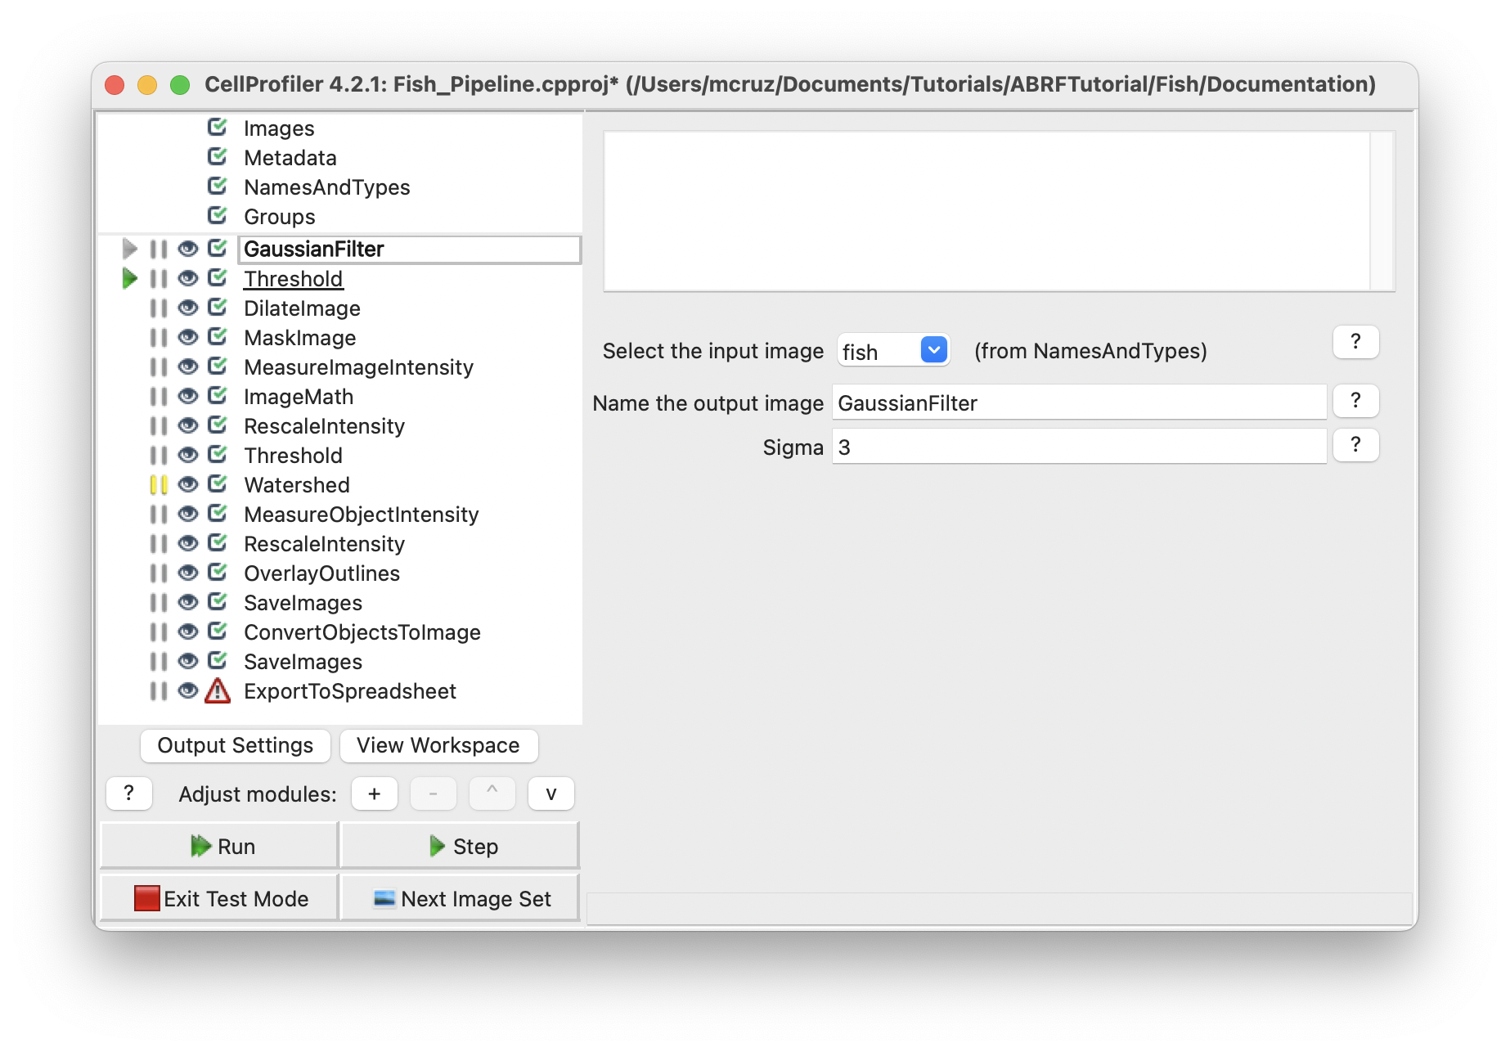

Hit the Step button and a new window will pop up with a resulting image that should look like this. The image can vary depending on the Image set choosed.

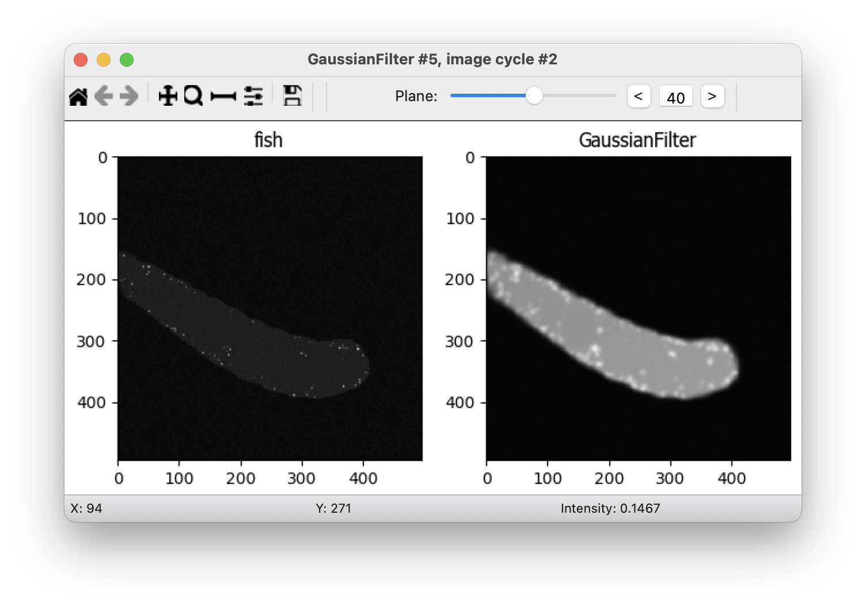In this part of the pipeline we want to identify the worm and not the spots, so we added a Threshold module to segment the worm.

1. **Threshold** module. This module produces a binary, or black and white, image based on a threshold that can be pre-selected or calculated automatically using one of many methods. After the threshold value has been determined, the Threshold module will set pixel intensities below the value to zero (black) and above the value to one (white).
   1. Select the input image: GaussianFilter (from **GaussianFilter** module)
   2. Name the output image: Threshold
   3. Threshold strategy: Global (We choose a global threshold strategy here because the out of worm background is relatively uniform after the gaussian filter).
   4. Threshold method: Minimum-Cross-Entropy (analyze the intensity distribution probability using the image histogram and define foreground and background)
   5. Threshold smoothing scale: 0.0 (Smoothing improves the uniformity of the resulting objects, by removing jagged edges caused by noise in the acquired image, because we used a gaussian filter module before this module, it’s not necessary to smooth the image prior to the threshold).
   6. Threshold correction factor: 1

**Tip:** To view pixel intensities in an open image, move your mouse over the image, the pixel intensities will appear in the bottom bar of the display window.

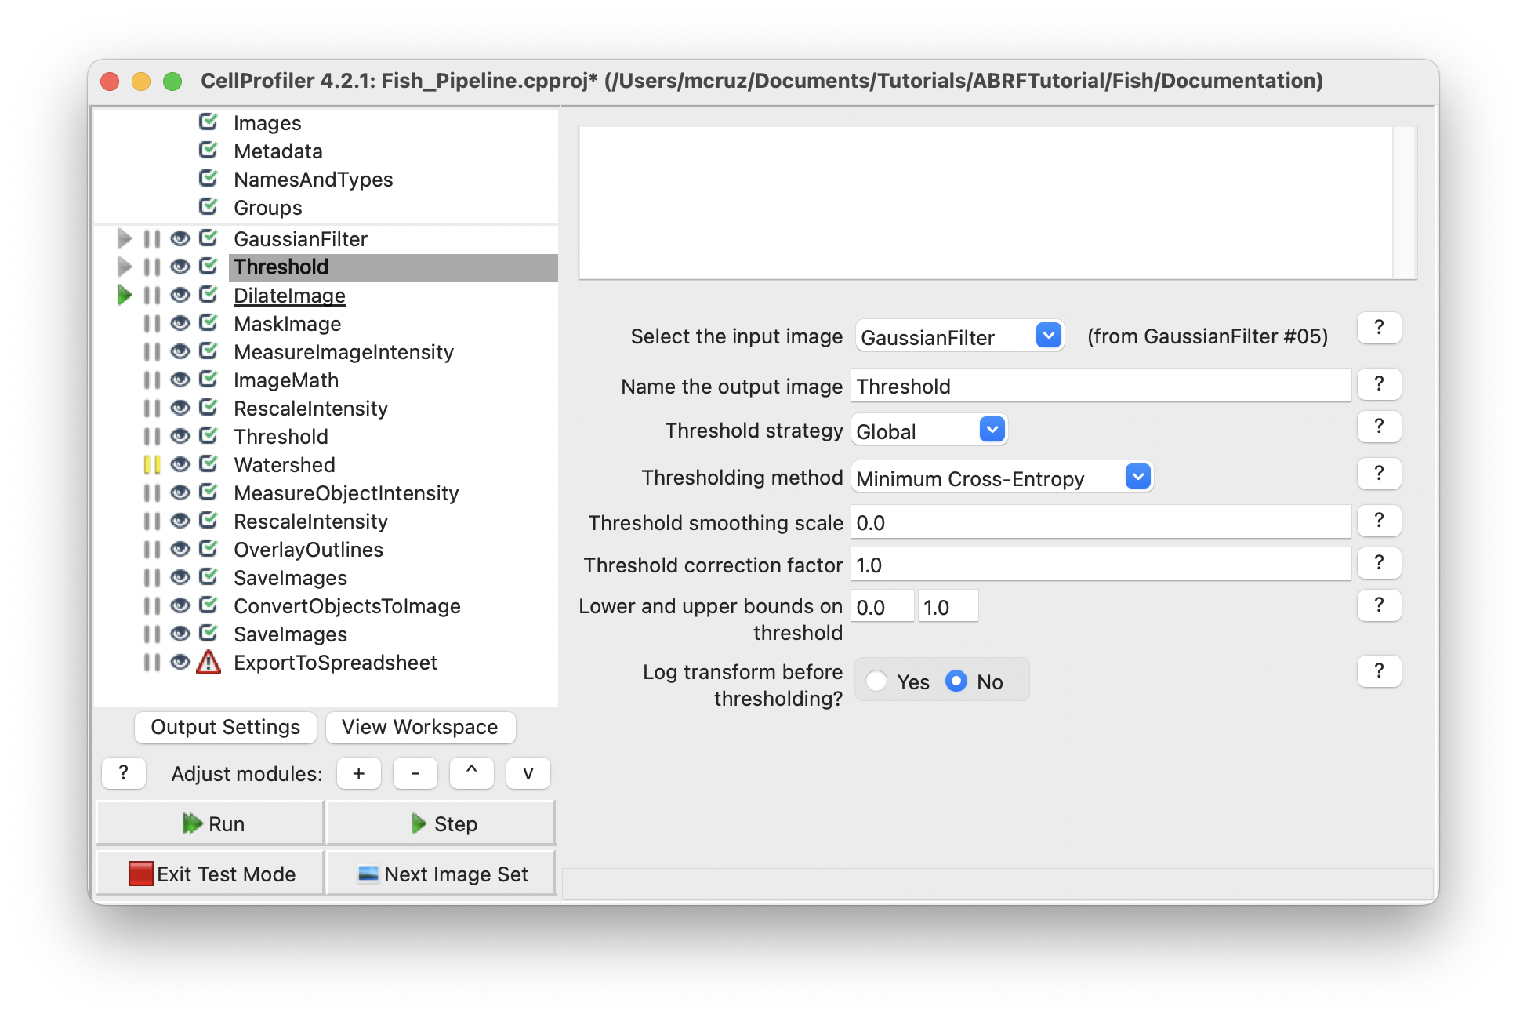

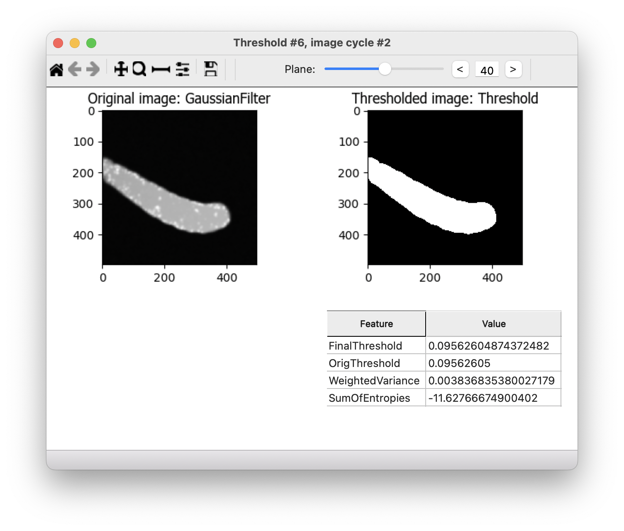

4. **DilateObjects** module. The objective of this first part of the pipeline is to remove the background and the noise on images without removing information, so dilate the object will prevent objects touching the edge of the worm to be removed in the following steps.

* 1. Select the input object: Threshold
  2. Name the output object: DilateImage
  3. Structuring element: Ball (Size: 3) ( dilate the objects using a ball shape with size of 3).

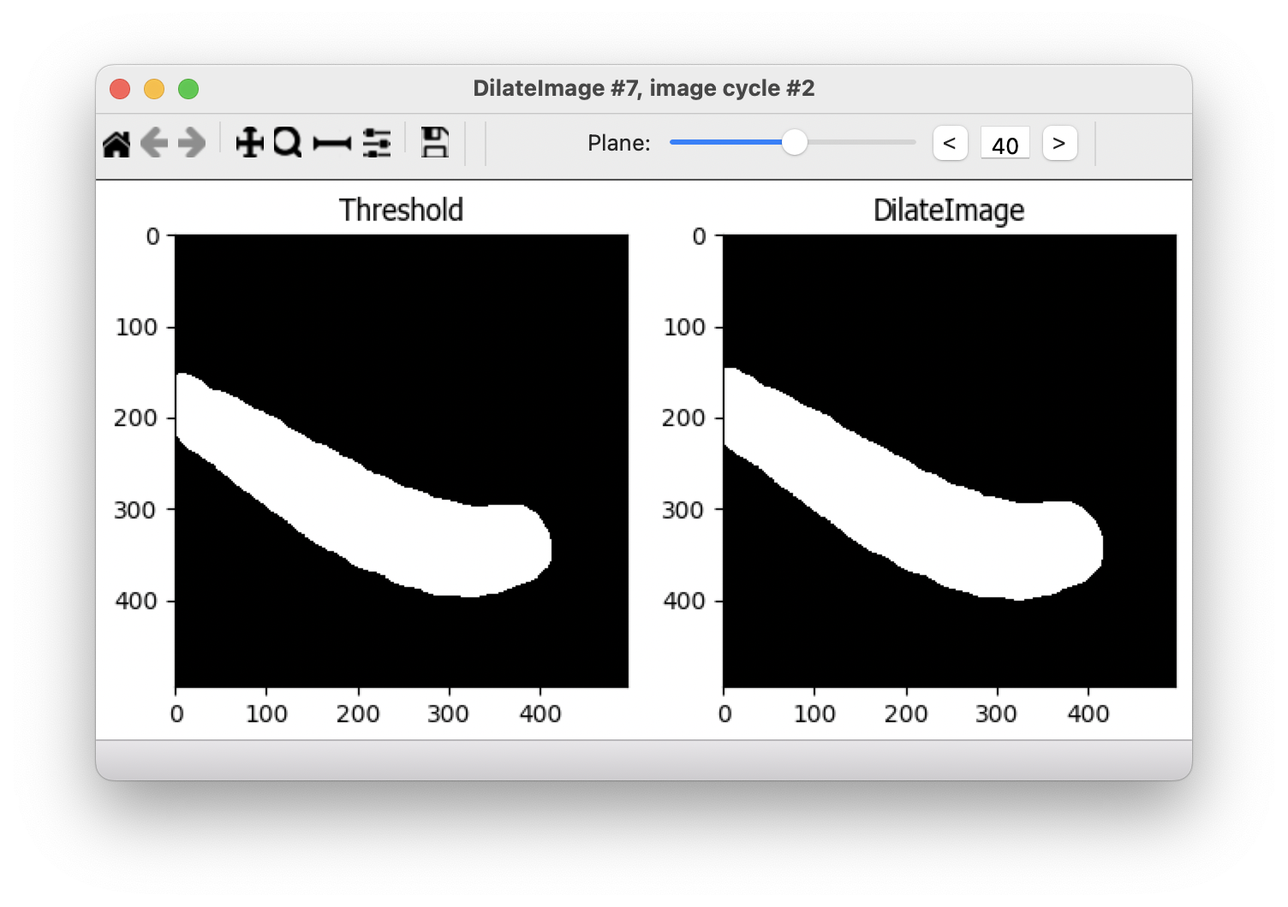

5. **MaskImage** module. This module will hide the out of worm portions of an image (based on previously identified objects or a binary image) so they are ignored by subsequent mask-respecting modules in the pipeline.

* 1. Select the input image: fish (from **NamesAndTypes** module)
  2. Name the output image: MaskWorm
  3. Use objects or an image as a mask?: Image
  4. Select image for mask: DilateImage (from **DilateImage** module)
  5. Invert mask?: No (select the worm and not the background)

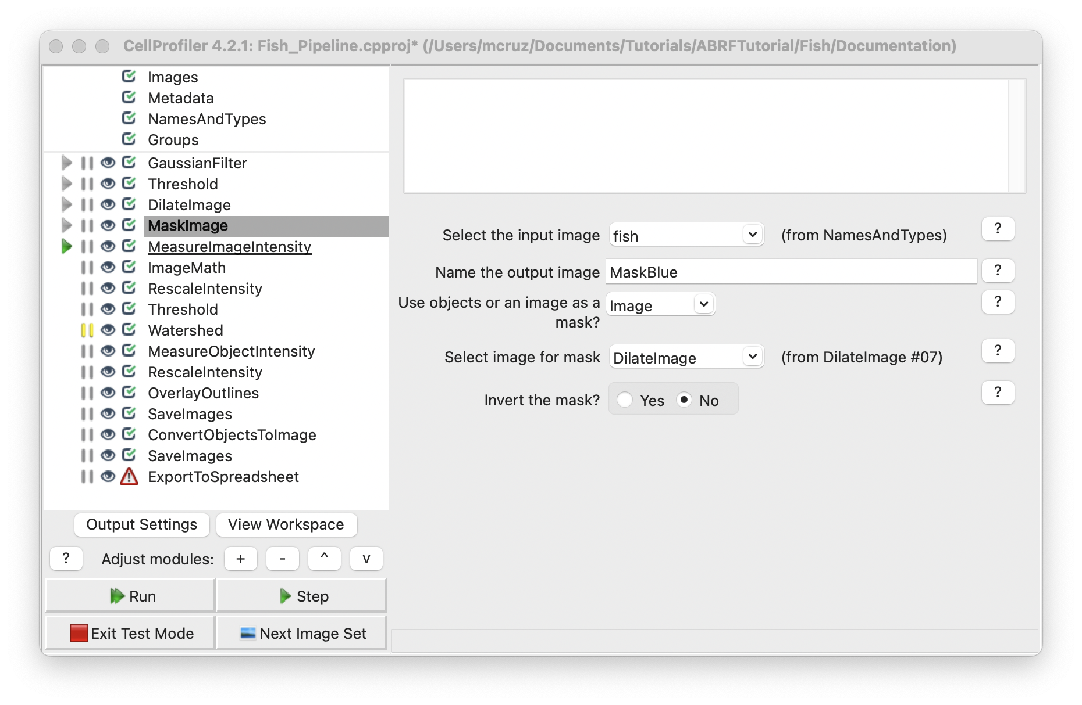

The resulting image looks the same as the original image, but the pixels out the worm has a value of 0.

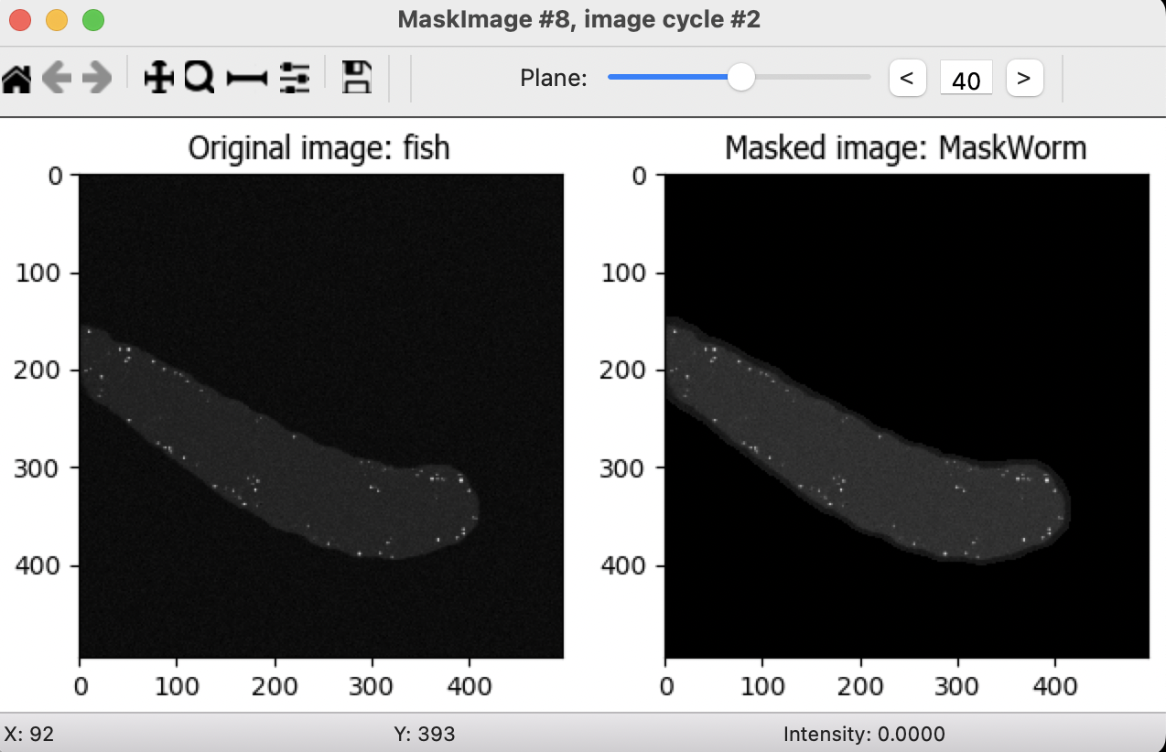

5. **MeasureImageIntensity** module. This module measures several intensity features across an entire image (excluding masked pixels). So we use the MaskWorm image to measure the only worm intensity. The background (most of the pixels) pixels have a huge height on the mean, median or mode intensity and can be used in the next module to extract the background image.

* 1. Select images to measure: MaskWorm (from **MaskImage** module)
  2. Measure the intensity only from areas enclosed by objects: No
  3. Calculate custom percentiles: No

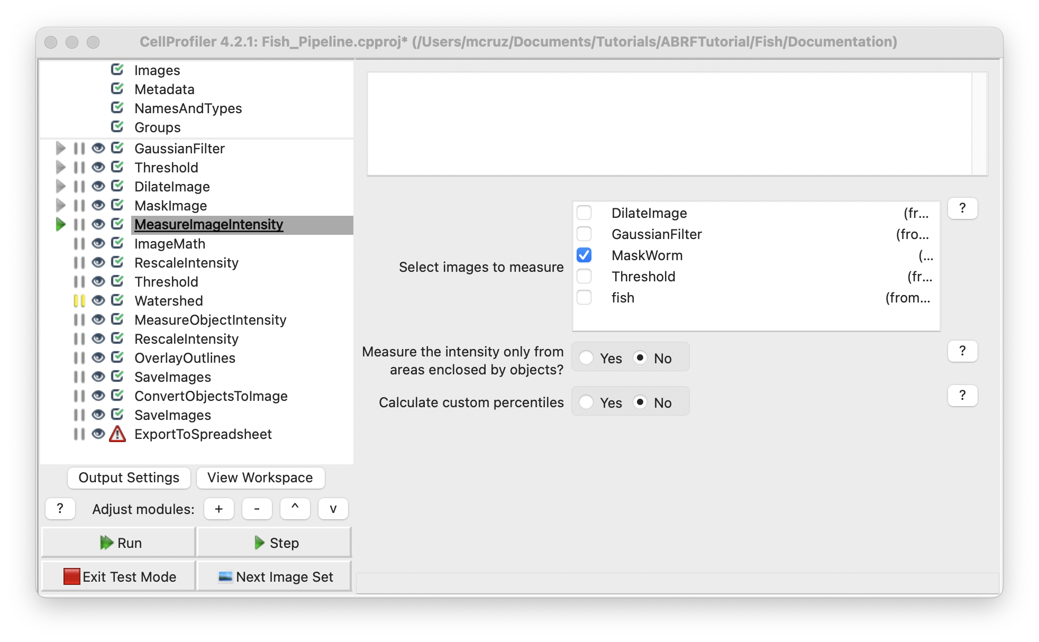

**6. MeasureImageIntensity** module. Performs simple mathematical operations on image intensities. This module can perform addition, subtraction, multiplication, division, or averaging of two or more image intensities, as well as inversion, log transform, or scaling by a constant for individual image intensities.

* 1. Operation: Subtract
  2. Name the output image: ImageAfterMath
  3. Image or measurement?: Image
  4. Select the first image: MaskWorm (from **MaskImage** module)
  5. Multiply the first image by: 1.0
  6. Image or measurement?: Measurement
     1. Category: Intensity (Select a measurement made on the image. The value of the measurement is used for the operand for all of the pixels of the other operand’s image)
     2. Measurement: MedianIntensity
     3. Image: MaskWorm (the image you choose in the **MeasureImageIntensity** module)
  7. Multiply the second image by: 1.0

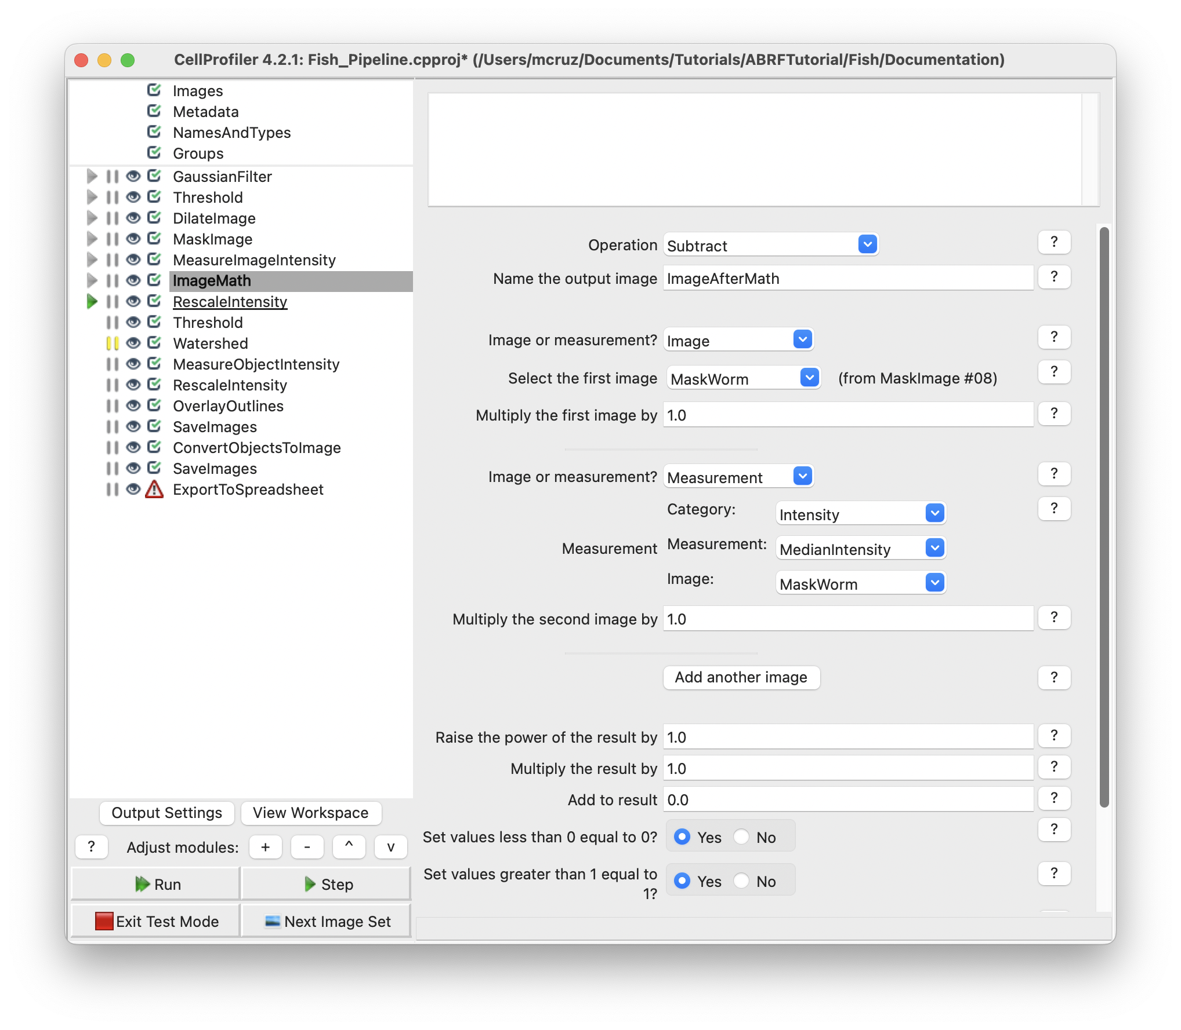

The resulting image shows just the spots without the background of the worm.

**Tip: The image tools on the top toolbar may be helpful to see the details on your image/objects:**

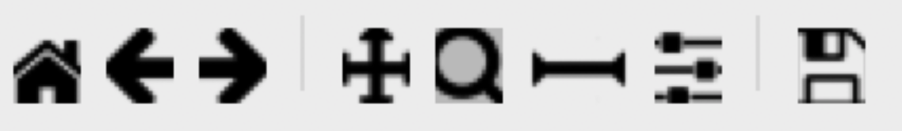

The 1st icon from the left lets you reset the view back to the original view.

The 2nd and 3rd icons let you step backwards and forwards through any changes you made to the view.

The 4th icon lets you change the view by moving in any direction in the display, by clicking and dragging.

The 5th icon lets you change the view by zooming, by dragging and drawing a box to zoom in on.

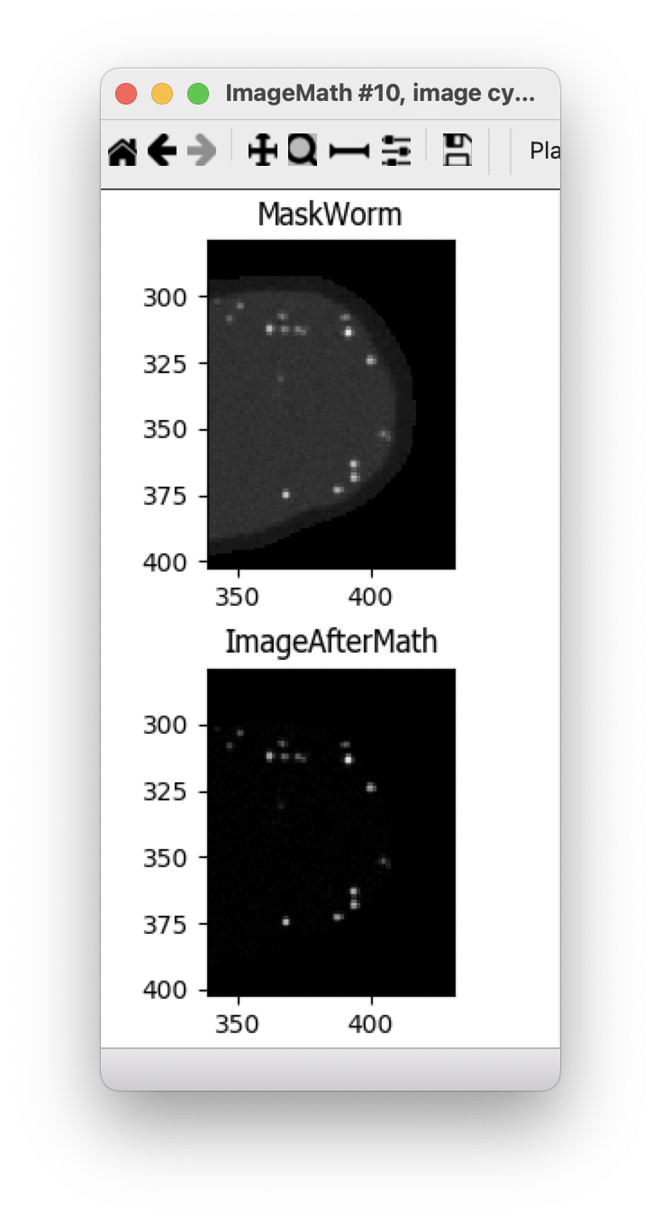

7. **RescaleIntesity** module. This module lets you rescale the intensity of the input images by any of several methods. The ImageMath module results in a final image with a substantially different range of pixel intensities than the original and this could make the segmentation process harder because the pixel intensities could have a small range.

* 1. Selecting the input image image: ImageAfterMath (from **ImageAfterMath** module)
  2. Name the output image: RescaleIntensity
  3. Rescaling method: Stretch each image to use the full intensity range (Find the minimum and maximum values within the unmasked part of the image (or the whole image if there is no mask) and rescale every pixel so that the minimum has an intensity of zero and the maximum has an intensity of one).

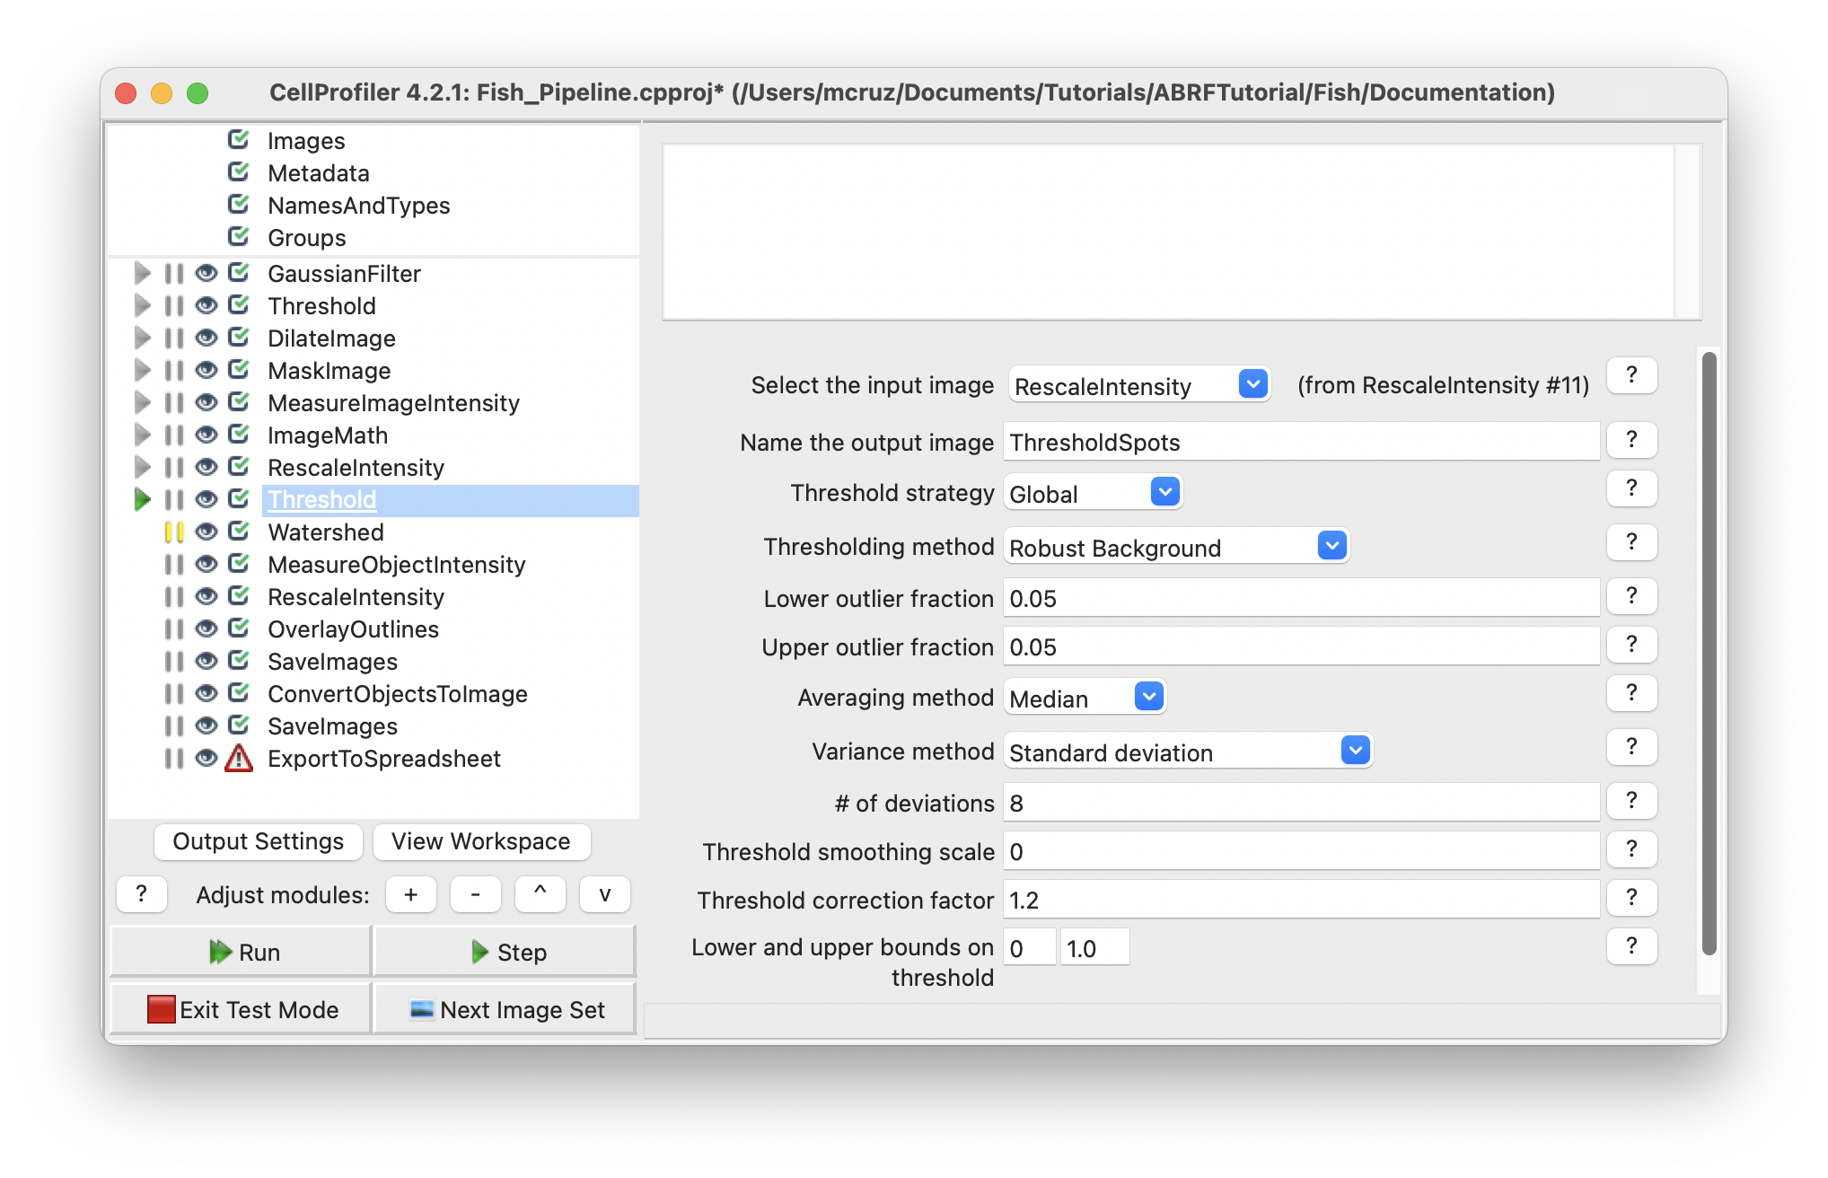

The resulting image looks the same, but the pixel value differs between images.

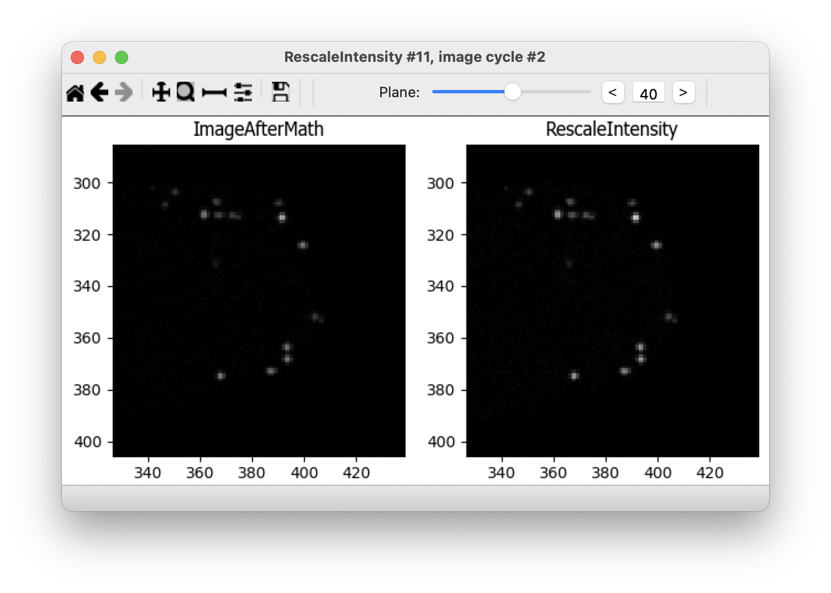

**Segmentation**

After removing the worm background on different image sets we can start the segmentation process.

1. **Threshold** module.
   1. Select the input image: ReduceNoise (from **ReduceNoise** module)
   2. Name the output image: ThresholdSpots
   3. Threshold strategy: Global
   4. Threshold method: Robust Background (This method can be helpful if the majority of the image is background).
   5. Lower outliner fraction: 0.05 (discard this fraction of dim objects).
   6. Upper outliner fraction: 0.05 (discard this fraction of bright objects).
   7. Averaging method: Median (This is a good choice if the spot density is variable or high).
   8. Variance method: Standard deviation
   9. # of deviations: 8 (value to multiply the calculated variance. Adding several deviations raises the threshold well above the average).
   10. Threshold smoothing scale: 0 (the objects are too small, smoothing before the threshold results in a larger object)
   11. Threshold correction factor: 1.2 (adjust the threshold to be more strict)
   12. Lower and upper bounds on threshold: 0, 1.0 (default)

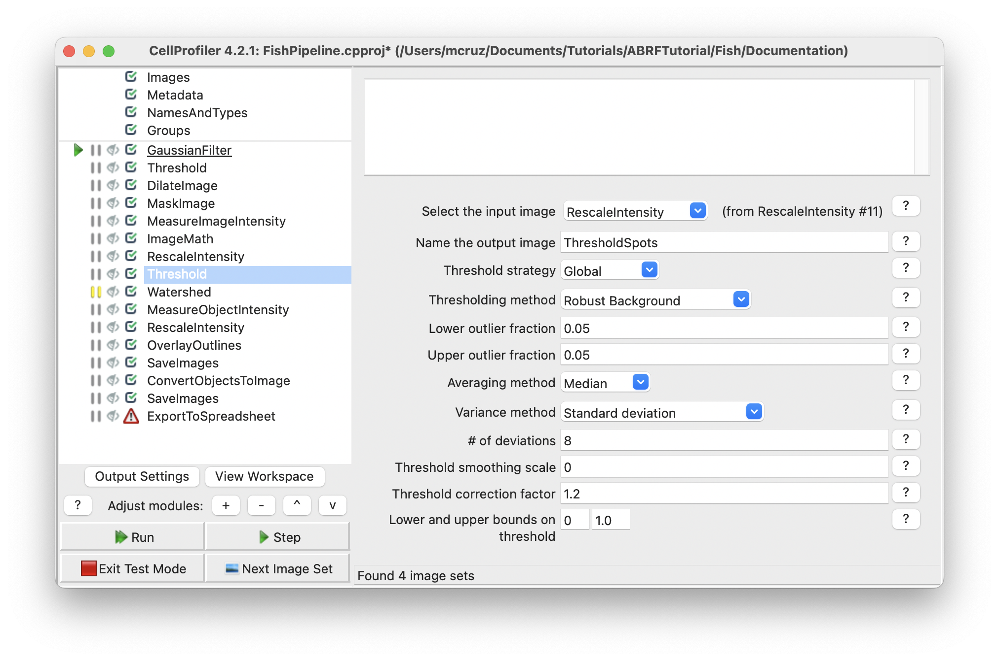

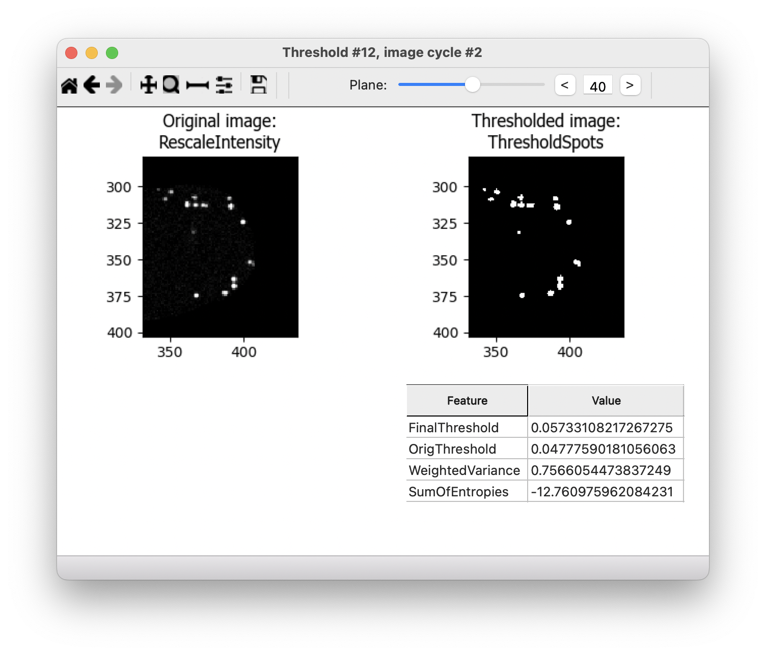

1. **Watershed** module. This module is used to separate different objects in an image, which in this case will segment the nuclei.
   1. Use advanced settings: Yes
   2. Select the input image: ThresholdSpots (from **Threshold** module)
   3. Name the output object: Spots
   4. Generate from: Distance (we don’t have markers to guide the segmentation process so the markers and other inputs for the algorithm will be automatically generated based on the footprint size).
   5. Footprint: 2(define the dimensions of the window used to scan the input image for local maxima, this will create a local maxima from a binary image that will be at the centers of objects. Large footprint will suppress local maximas that are close together into a single maxima, so two or more objects will be segmented as one. Small footprint can lead to oversegmenation, this means one nuclei segmented as two or more objects.
   6. Downsample: 1 (if the factor is 1, the image is not downsampled, the spots are too small, downsampling will remove objects).
   7. Declump method: Intensity
   8. Reference Image: MaskWorm (from **MaskImage** module)
   9. Segmentation distance transform smoothing factor: 0
   10. Minimum distance between seeds: 1
   11. Minimum absolute internal distance: 0.0
   12. Pixels from border to exclude: 0 (Default)
   13. Maximum number of seeds: -1 (Default no limit)
   14. Structuring element for seed dilation: Octahedron (Size: 1)

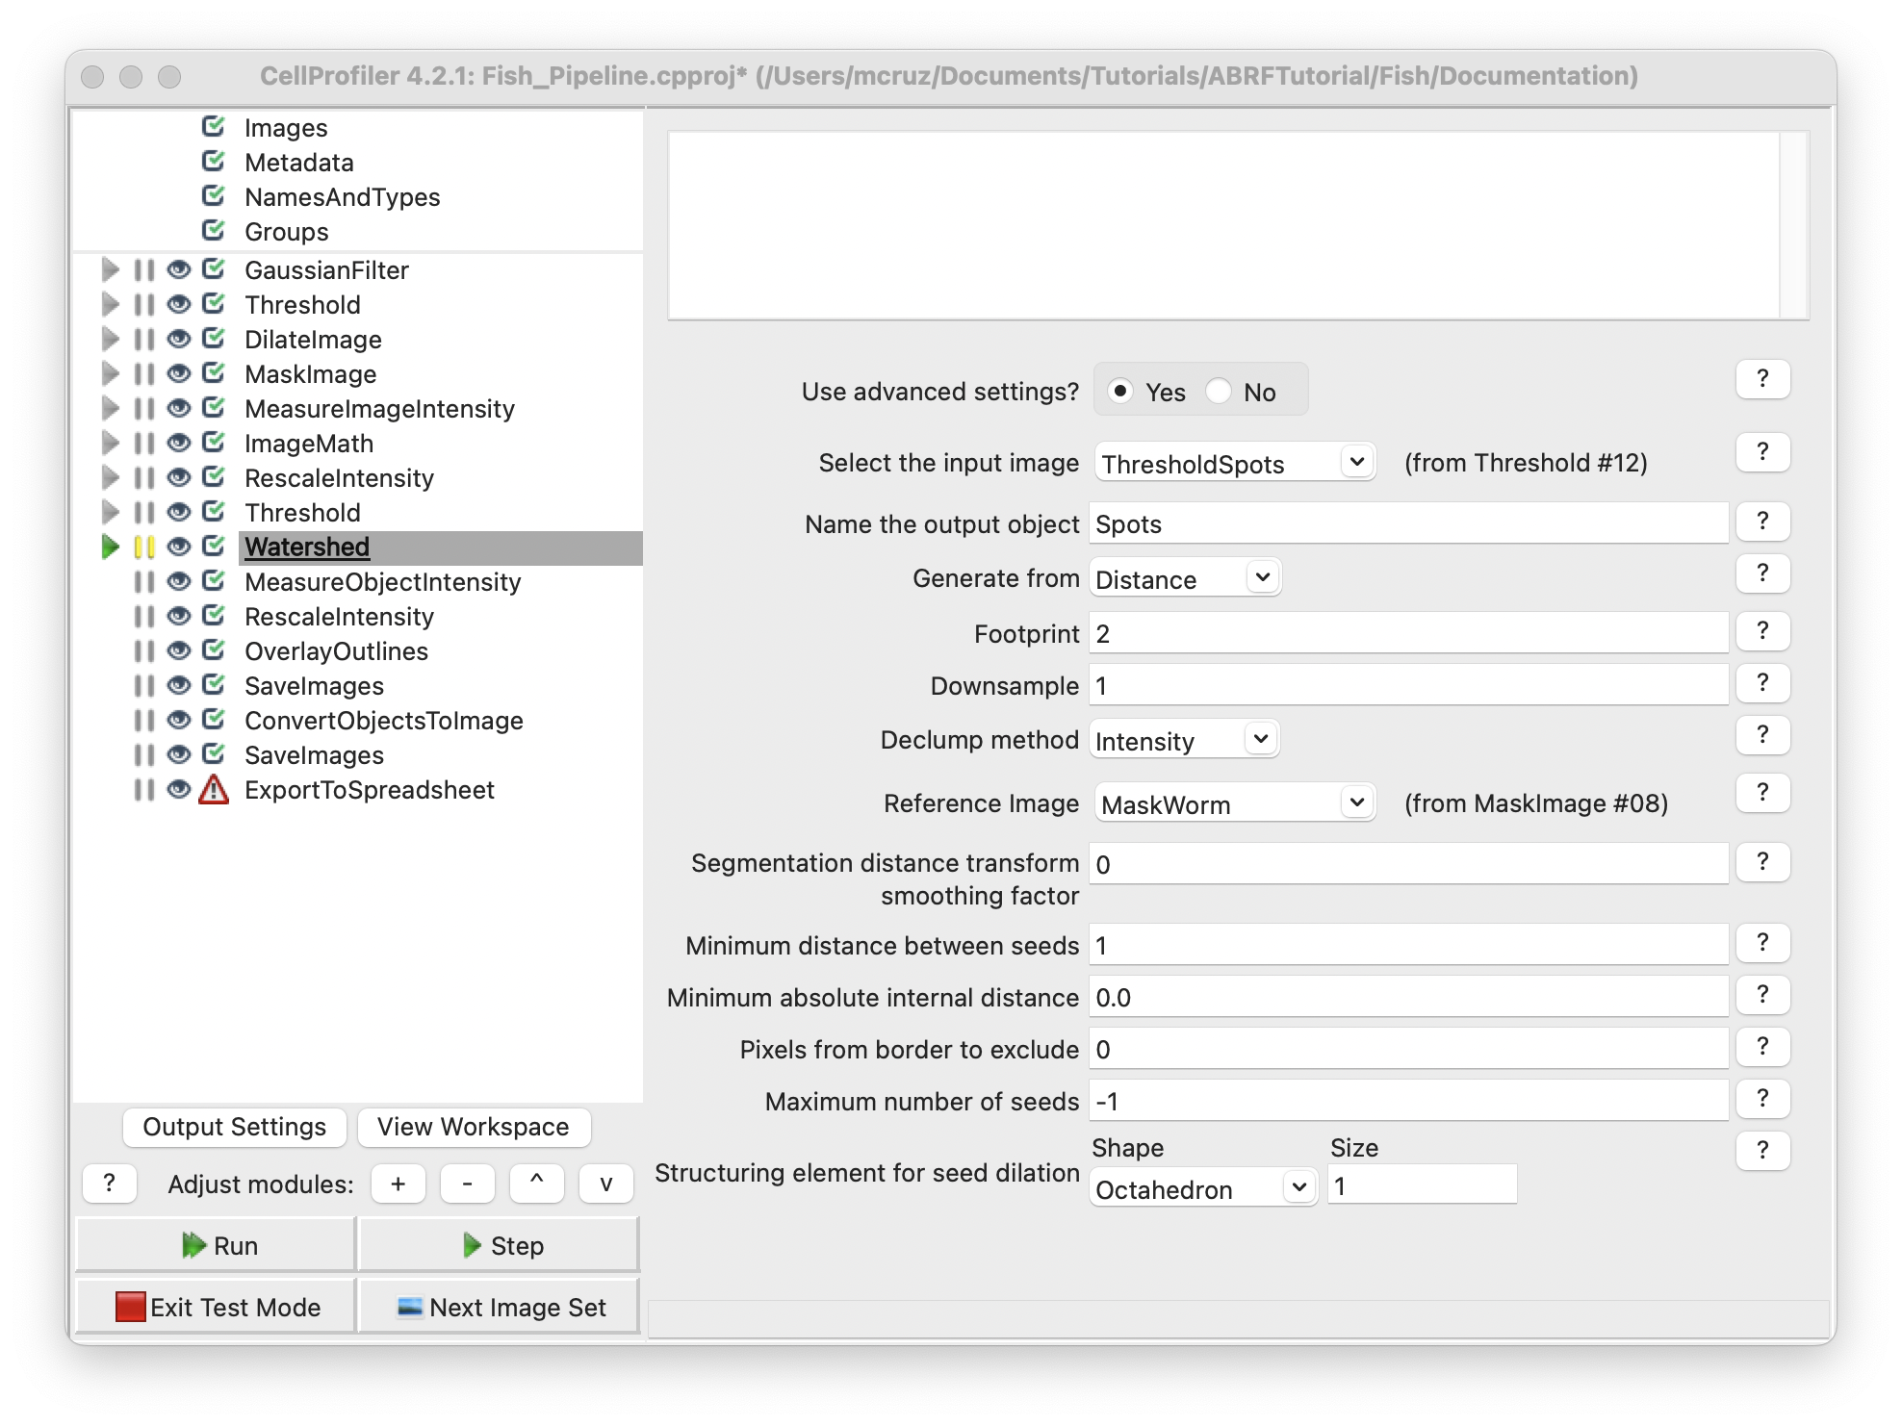

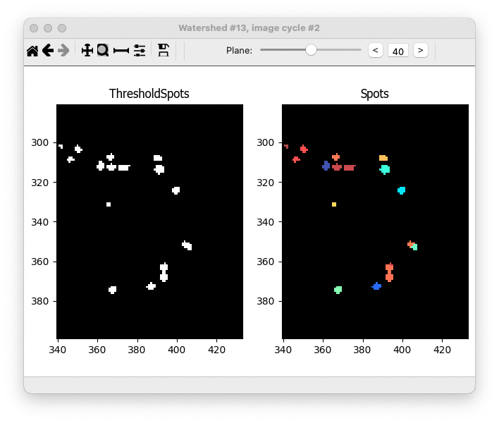

**Measure and export data**

Now that the spots have been segmented, measurements can be made using modules from the **Measurements** category. This study is asking for two particular measurements:

Centroid location (x, y and z),

Integrated intensity and

In this case we need the **MeasureObjectIntensity** module to extract this information.

**Note:** When applying these measurements, be careful to measure the original images, not rescaled or processed images.

1. **MeasureObjectIntensity** module
   1. Select images to measure: fish (original image from **NamesAndTypes** module)
   2. Select objects to measure: Spots (from **Watershed** module) to have all the intensity measurements from the object.

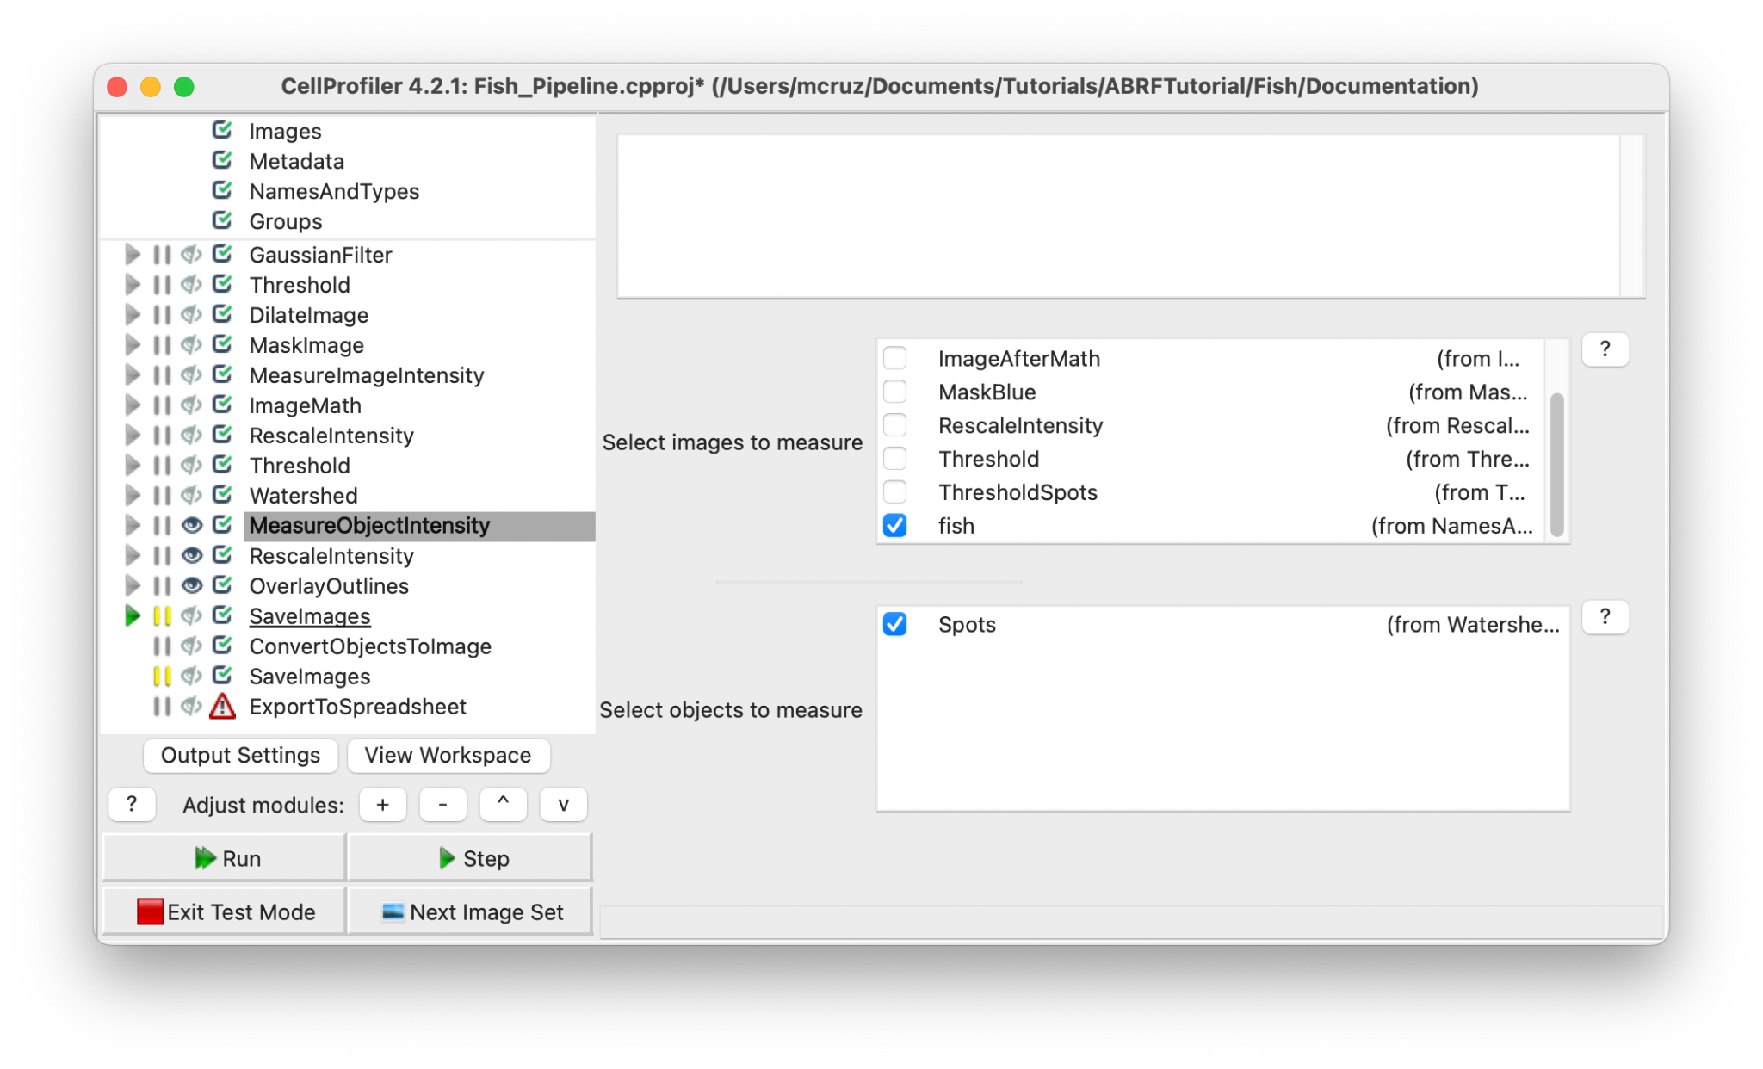

**Note:** The measure modules will provide several features for identified objects and at this point we cannot choose which measurement, so the module will extract all intensity features possible.

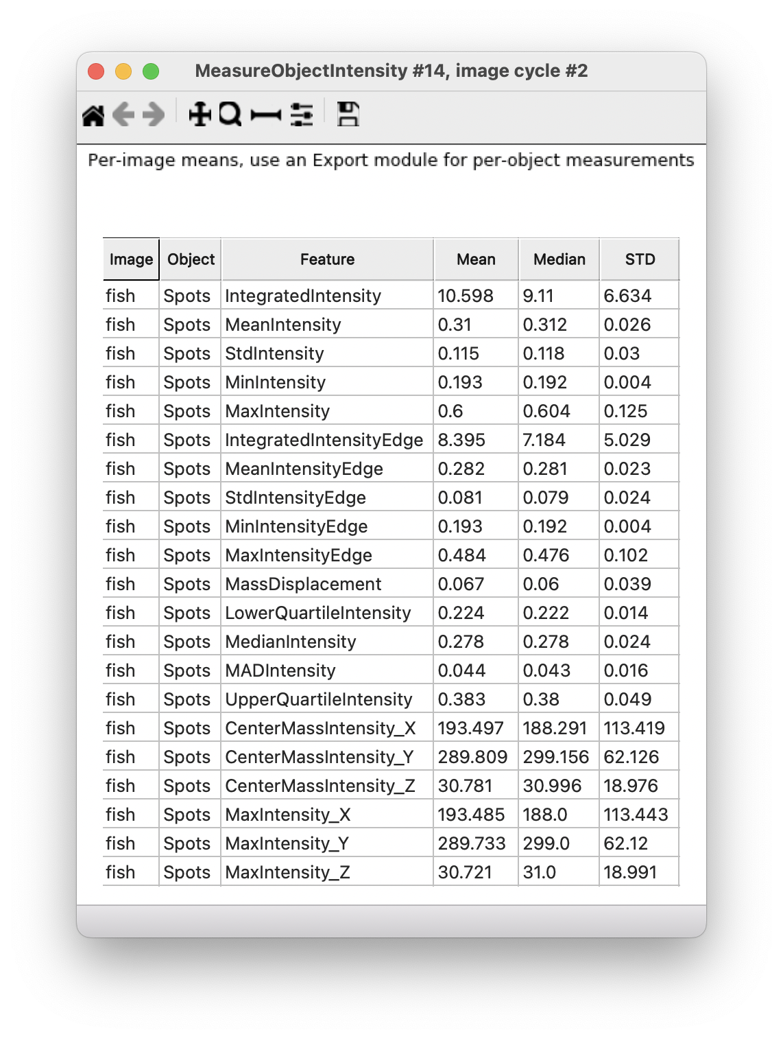

**Creating visuals**

1. Add the **RescaleIntesity** module to your pipeline. This module lets you rescale the intensity of the input images by any of several methods. You should use caution when interpreting intensity and texture measurements derived from images that have been rescaled because certain options for this module do not preserve the relative intensities from image to image.
   1. Selecting the input image image: fish (from **NamesAndTypes** module)
   2. Name the output image: RescaleIntensityFish
   3. Rescaling method: Stretch each image to use the full intensity range (Find the minimum and maximum values within the unmasked part of the image (or the whole image if there is no mask) and rescale every pixel so that the minimum has an intensity of zero and the maximum has an intensity of one).

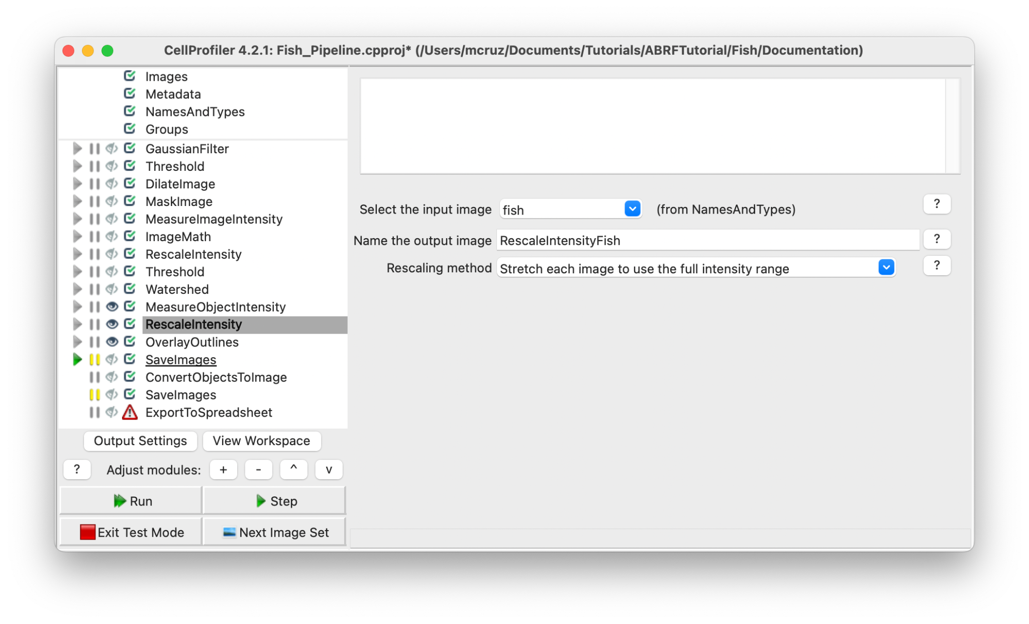

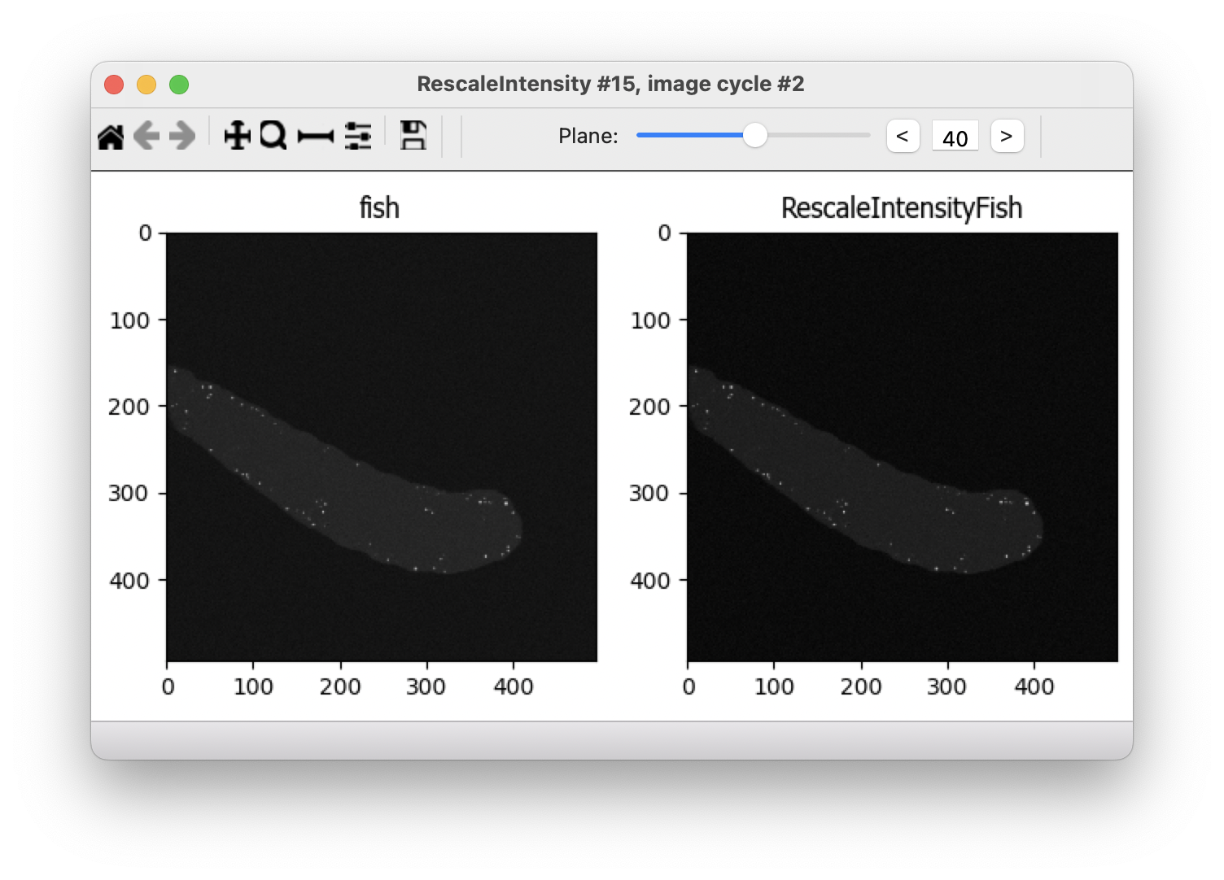

1. **OverlayOutlines** module. This module places outlines of objects over a desired image. We recommend overlaying onto rescaled images, which will be easier to visualize outside of CellProfiler.
   1. Display outlines on a blank image: No
   2. Select image on which to display outlines: RescaleIntensityFishi (from **RescaleIntensity** module)
   3. Outline display mode: Color
   4. How to outline: Outer
   5. Select objects to display: Spots (from **Watershed** module)
   6. Select outline color: Red (Default).

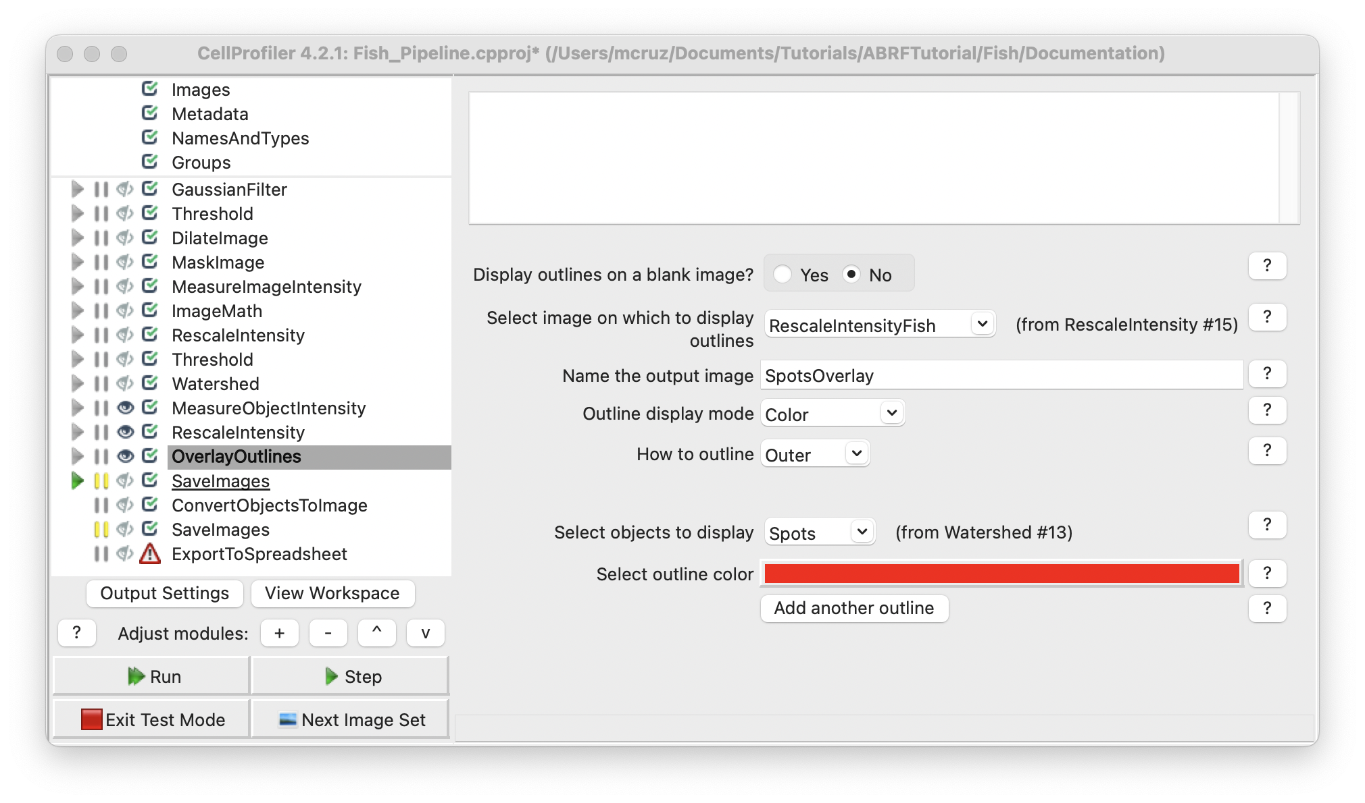

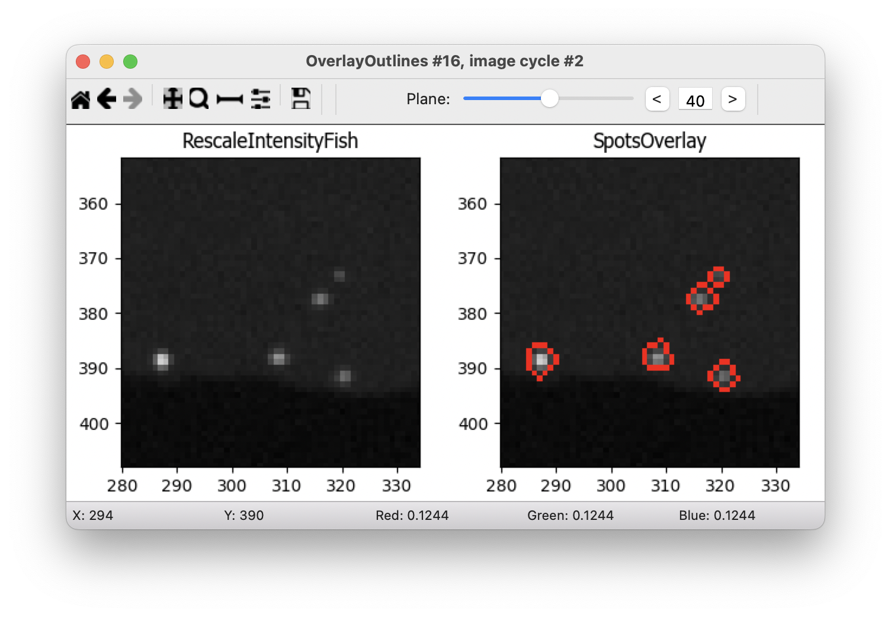

3. **SaveImages** module. This module saves image or movie files. Because CellProfiler usually performs many image analysis steps on many groups of images, it does not save any of the resulting images to the hard drive unless you specifically choose to do so with the SaveImages module. You can save any of the processed images created by CellProfiler during the analysis using this module. You can choose from many different image formats for saving your files. This allows you to use the module as a file format converter, by loading files in their original format and then saving them in an alternate format.

* 1. Select the type of image to save: Image
  2. Select the image to save: SpotsOverlay (from **OverlayOutlines** module)
  3. Select method for constructing file names: From image filename (use this option to avoid reassignment of your images)
  4. Select image name for file prefix: fish (select the original image name from NamesAndTypes module)
  5. Append a suffix to the image file name?: No
  6. Saved file format: tiff (tiff is a lossless format, but you can choose others depending on what you need to do with this images)
  7. Image bit depth: 8-bit integer (this bit depth is easily read outside Cell Profiler)
  8. Save with lossless compression: Yes
  9. Output file location: Default Output Folder (or create a new folder just for this images)
  10. Overwrite existing files without warning?: No (prevent file overwritten)
  11. When to save: Every cycle (Save every image set)
  12. Record the file and path information to the saved image?: No
  13. Create subfolders in the output folder: No

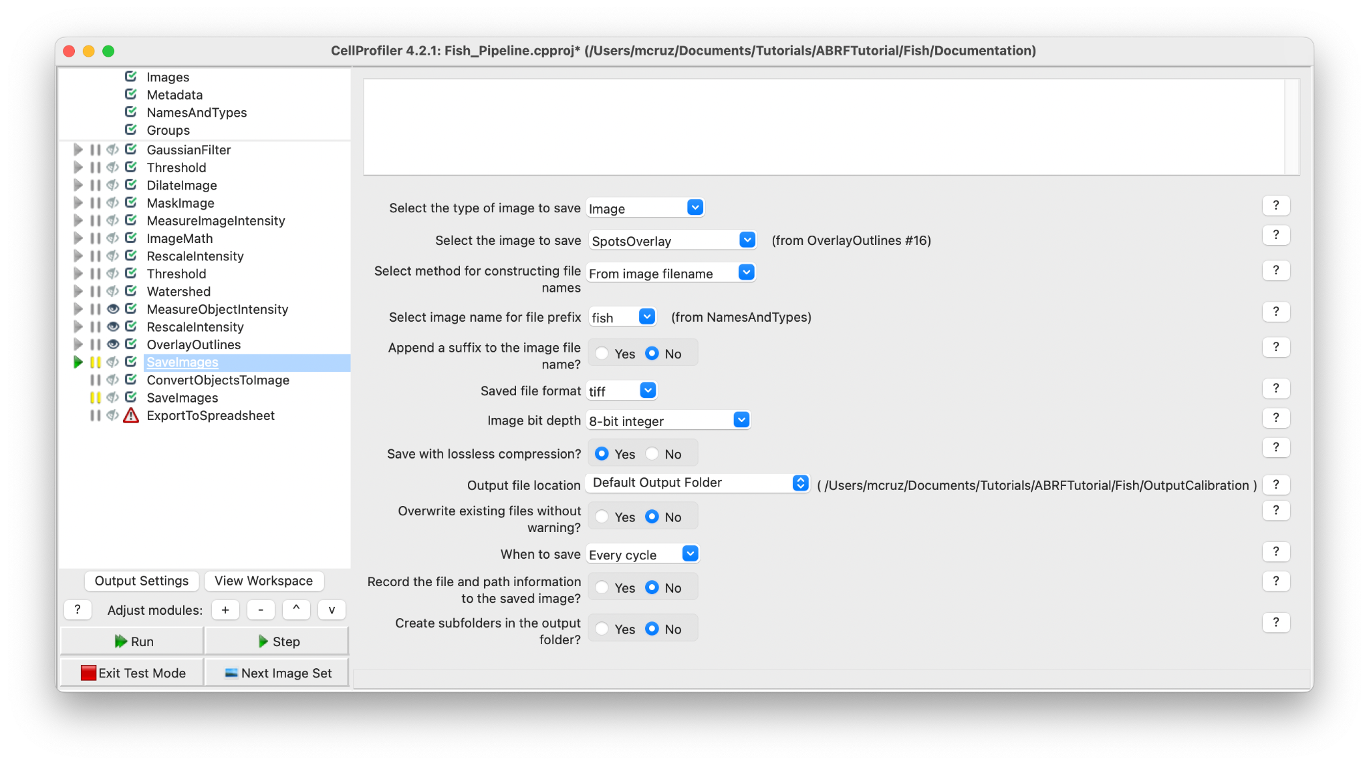

4. **ConvertObjectsToImage** module. Transform objects in image (provide a 3D volume image of the segmented image)

* 1. Select the input objects: Spots (from Watershed module)
  2. Name the output image: SpotImage
  3. Select the color format: Grayscale

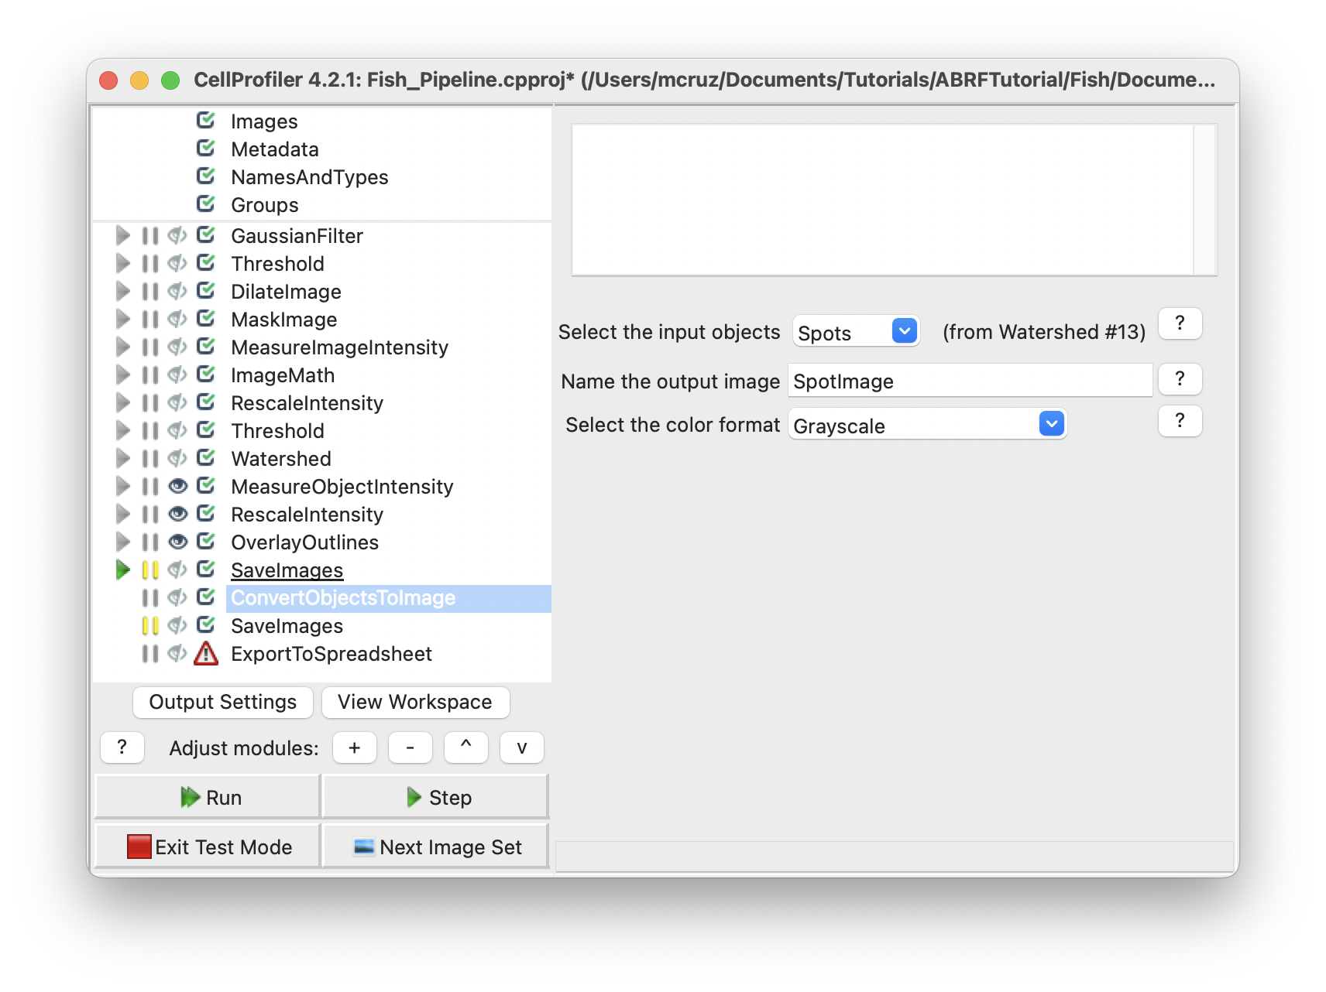

5. **SaveImages** module. This option will allow you to visualize the segmentations outside Cell Profiler.

**Export measurements**

It’s good practice to place all export modules at the end of your pipeline. CellProfiler automatically calculates execution times for each module that was run before the export module. By placing your export modules at the end of your pipeline, you will have access to module execution times for each module in your pipeline. Save the output of the measurement modules using **ExportToSpreadsheet** or **ExportToDatabase**.

**ExportToSpreadsheet** module. This module exports measurements into one or more files that can be opened in Excel or other spreadsheet programs. This module will convert the measurements to a comma-, tab-, or other character-delimited text format and save them to the hard drive in one or several files, as requested.

1. Select the column delimiter: Comma (“,”)
2. Output file location: Default Output Folder
3. Add a prefix to file names: Yes
4. Filename prefix: FISH
5. Overwrite existing files without warning: No
6. Add image metadata columns to your object data file: No
7. Add image file and folder names to your object data file: No
8. Representation of Nan/Inf: NaN
9. Select the measurements to export: Yes
10. Press button to select measurements:
    1. Spots:
       1. Intensity: IntegratedIntensity
    2. Location
       1. Center: X, Y and Z
11. Calculate the per-image mean values for object measurements?:No
12. Calculate the per-image median values for object measurements?:No
13. Calculate the per-image standard deviation values for object measurements?:No
14. Output file location:Default Output Folder|
15. Create a GenePattern GCT file?:No
16. Export all measurement types?:No
17. Data to export: Spots
18. Use the object name for the file name?: No
19. File name: Spots.csv
20. Data to export: Experiment
21. Use the object name for the file name?: No
22. File name: Metadata.csv

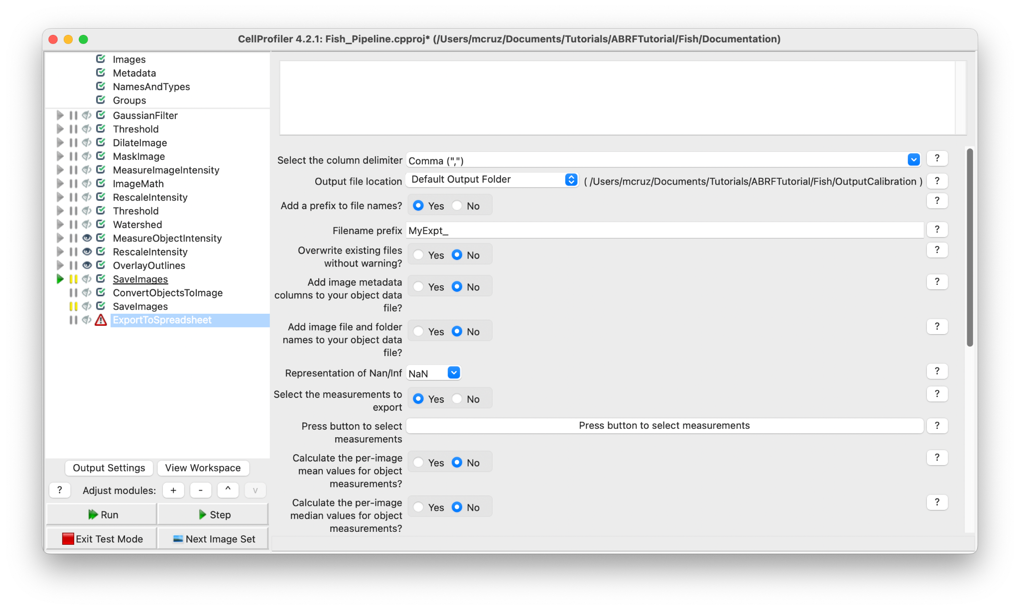

**Congratulations!** The spots have been segmented, measured and exported. Now we need to convert the units from the csv file generated in Cell Profiler to microns and create a new table with just the values asked by the Study (X, Y, Z positions and Integrated Intensity for each spot).

For this purpose we create an interactive colab notebook that will ask you the X, Y and Z values, upload the csv generated by Cell Profiler to finally export a new csv file with the normalized values.

https://colab.research.google.com/drive/19Xmna9BKQIkm2qmoW9IOZn-smwuAg-vu?usp=sharing

**End**